Project Title:

Zebra Printer Management

Helpdesk Reference:

#14044

Revision:

B

Date:

2018-06-25

Author:

Ryan J. Dumais

Table of Contents

1. Introduction 2

2. Background 2

3. Definitions 2

4. Impacted Objects 2

4.1. Forms 2

4.2. Processes 2

4.3. Output 2

5. Description 2

5.1. Appearance 2

5.2. Behavior 3

6. Limitations 3

7. Screen Captures 4

# Introduction

This change will integrate the Zebra Printers into Syteline and Samanage help desk. It provides central management and a real-time print count. In addition to the Syteline form, the user will be able to reset the current print count, reset the print head replacement count, and automatically close an active ticket in the Samanage help desk including:

* Changing the requester to the Quality Assurance Supervisor (Brian Larose)
* Changing the assignee of the ticket to the Syteline form user
* Attaching the appropriate configuration item (Zebra printer) to the ticket
* Commenting the previous and current print count
* Closing the ticket

# Background

To create a streamlined process that handles the preventative maintenance records while removing the possibility of human error.

# Definitions

cURL - a computer software project providing a library and command-line tool for transferring data using various protocols.

# Impacted Objects

## Forms

* LSC14044_ZebraPrinterManagement (Zebra Printer Management)

## Processes

* Resetting print count of Zebra printers
* Documenting the Zebra printers’ print count history

## Output

* N/A

# Description

## Appearance

The form will include a set of buttons for each of the Zebra Printers each performing an action relevant to the specified printer. Each printer on the form displays it’s current print count since last reset. See section 7 for screen captures of the form.

## Behavior

All Zebra label printers will be able to have their print count or print head replacement count reset with a click of a button. The two nameplate department printers will have an additional button that will automate the closing and documentation of the Samanage help desk ticket.

The ‘Close Ticket’ button utlizes Samanage’s API and will send a cURL requests to LSC-SV-WEB1 in order to interact with the open preventative maintence ticket record. The buttton will also prompt the user with the status of the response from the server depending on success or cURL failures.

# Limitations

The script will handle the latest ticket for the printer that is not in a closed/resolved state. Any duplicated tickets submitted by WUG will need to be manually closed.

# Screen Captures

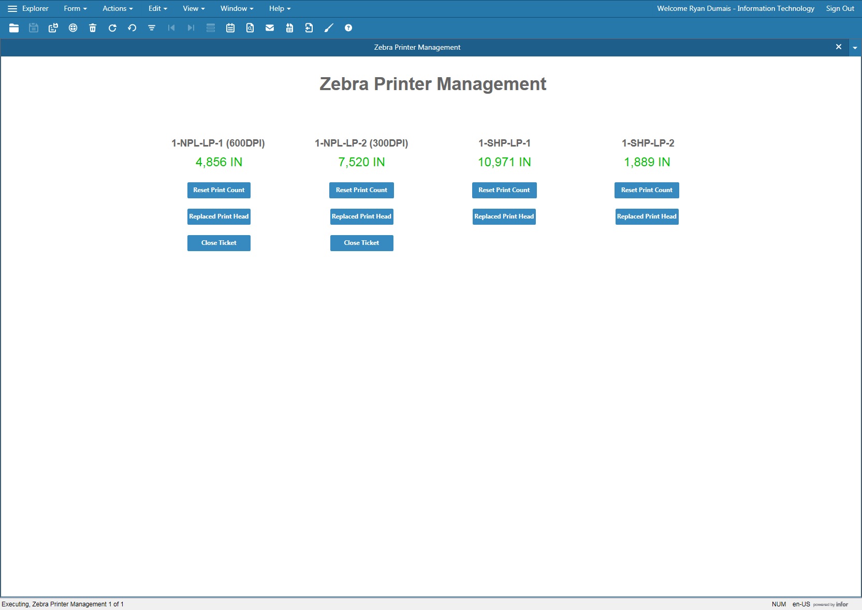

The Zebra Printer Management form

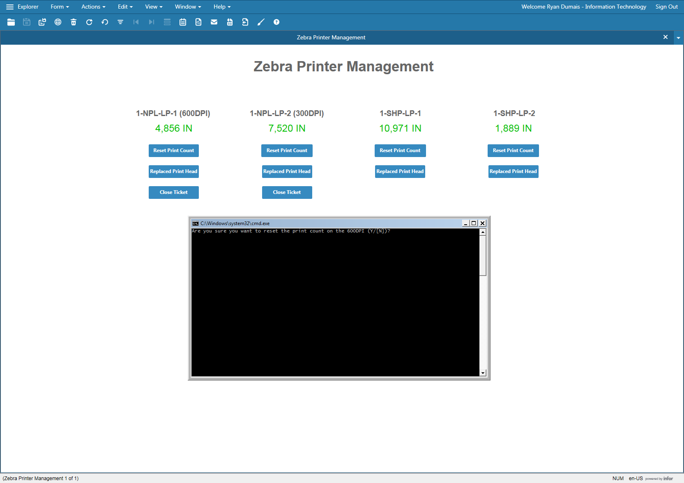

Confirmation before resetting a printer’s print count

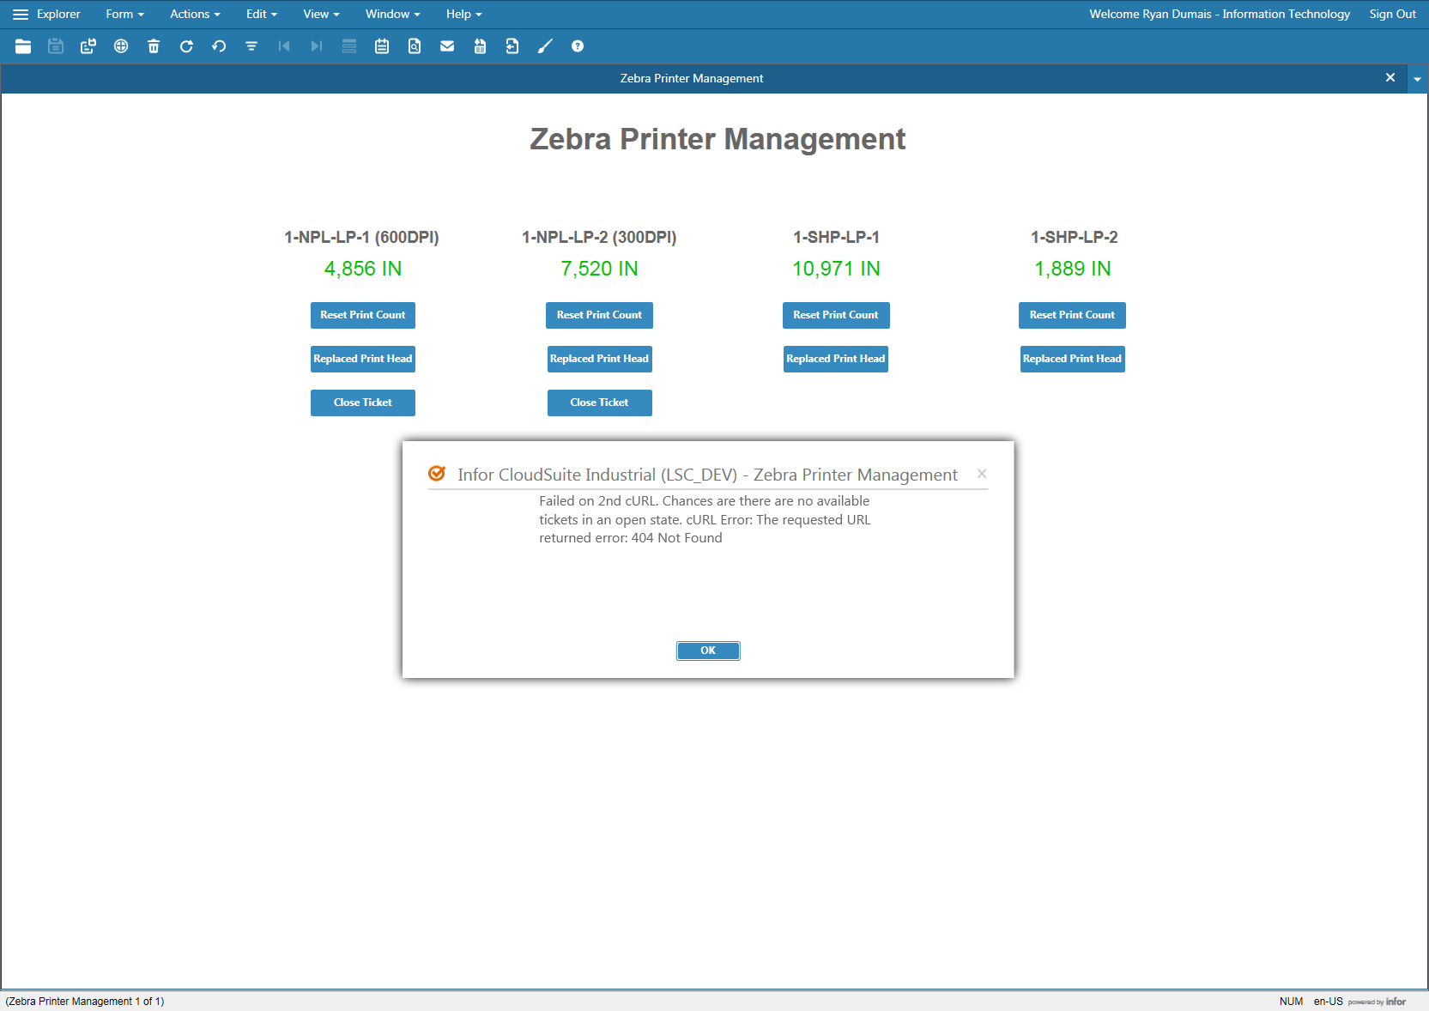

A response from the server indicating a fail in the cURL request. The error messages are handled within the script that the server uses.